System Design

Specification

for

Project Title: Garden Planner

Project Members: Morgan Matchette, Patrick Jolly, Austin Hargis

Version: 1.0

Date: 03/30/21

Contents

1. **Document Management**
   1. Purpose
   2. Scope
   3. Objective
2. **Overview**
   1. Hardware Interfaces
   2. Software Interfaces
   3. Memory Constraints
   4. Site Adaptation Requirements
3. **Development Tools**
4. **System Processes**
   1. Account Registration
   2. Zone Search
5. **User Interface**
   1. Expected Input
   2. Output
6. **Application Security**
   1. SHA-256 Encryption
7. **Database Design**
8. **Document Management**
   1. **Purpose**

This Systems Design Specification document exists for the purpose of defining the design for a web-based garden planner application. Throughout this document, there is information regarding different inputs, outputs, functions, classes, and other important core pieces to the application.

* 1. **Scope**

This System Design Specification document is to be used by the main contributors of the Garden Planner to ensure continued quality and improvement of the application.

* 1. **Objective**

Our Garden Planner application has been developed to offer a free and easy-to-use experience for gardeners looking to keep track of crucial information relating to the growth of their plants.

1. **Overview**

**2.1 Hardware Interfaces**

Our hardware requirements follow those of Php and MySql servers. At a minimum, we recommend a CPU with at least 2 cores, 2GB of RAM, and an SSD capable of the high I/O writes.

**2.2 Software Interfaces**

Garden Planner can run on any web server and any web operating system that supports Php, MySql, and JavaScript.

**2.3 Memory Constraints**

This website, while running MySql and Php, can consume at least 2GB of RAM during runtime, depending on the database size.

**2.4 Site Adaptation Requirements**

This website is designed to run on any web server with no modifications, so long as the desired web server supports Php and MySql.

1. **Development Tools**

Garden Planner uses several modern technologies to operate our website, including HTML5, Php 7.4, MySql, JavaScript, and more, including version control through Github.

1. **System Processes**

The processes that Garden Planner uses to operate are very minimal. We have a user account registration process and a zone search process. Both processes are depicted below with a flowchart demonstrating how the process is completed.

**4.1 Account Registration**

Upon entering the Account tab on the website, the user is prompted to login or create an account. If the user chooses to login, they are asked for their account credentials and, if the credentials match those stored in the database, are logged into the system and can begin using the site’s core functionality.

If the user decides to create an account, the user is asked to create credentials by entering information such as name, email, and password. If an account with that email address does not already exist, then the account can be created and the user will be logged in.

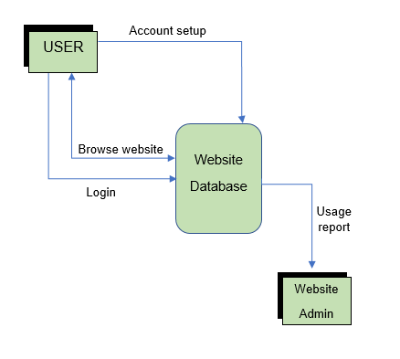

**4.2 Zone Search**

The zone search process occurs when the user inserts any piece of data regarding a plant, region, or other related information to find important information regarding the growth of a plant.

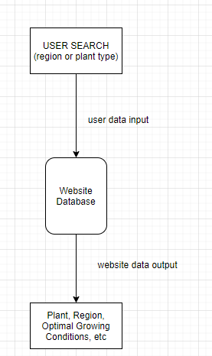

1. **User Interface**

Using the Garden Planner, users will be prompted to input information into text interfaces that appear on the website. The user may be prompted for several different pieces of information depending on which text interfaces they are engaging with.

* 1. **Expected Input**

The user is prompted to enter value for the following:

Username

Email

Password

Region

Plant Type

* 1. **Output**

Depending on what area the user put information into, they could receive a variety of outputs. If they have put information into the Account Registration or the Account Login screen, they will receive an error or a confirmation acknowledging the existence, or lack of, for an account.

If the user has put in information in the research field, they will receive data including regions, plants, weather, and other valuable information regarding the planting, growing, and raising of a variety of plants.

1. **Application Security**

**6.1 SHA-256 Encryption**

Garden Planner uses a cryptographic hash function to secure sensitive user information, such as passwords, to ensure security. The hashed password value is not encrypted before it is stored in the database. When a user attempts to log in, the supplied password is hashed and then compared to the value in the database. If the passwords match, the user is logged in successfully.

1. **Database Design**

The Garden planner database includes 6 tables: Plant, Zone, Plantzone, Lookup, Log, Login. Plant contains all plant data, Zone includes all zones, Plantzone connects the two tables, Lookup stores search data, Log holds user’s input from the plant log, and Login stores user login data.